**ASS LAB 3**

1. Write a program to print the lines of a file that contain a word given as the

program argument (a simple version of grep UNIX utility).

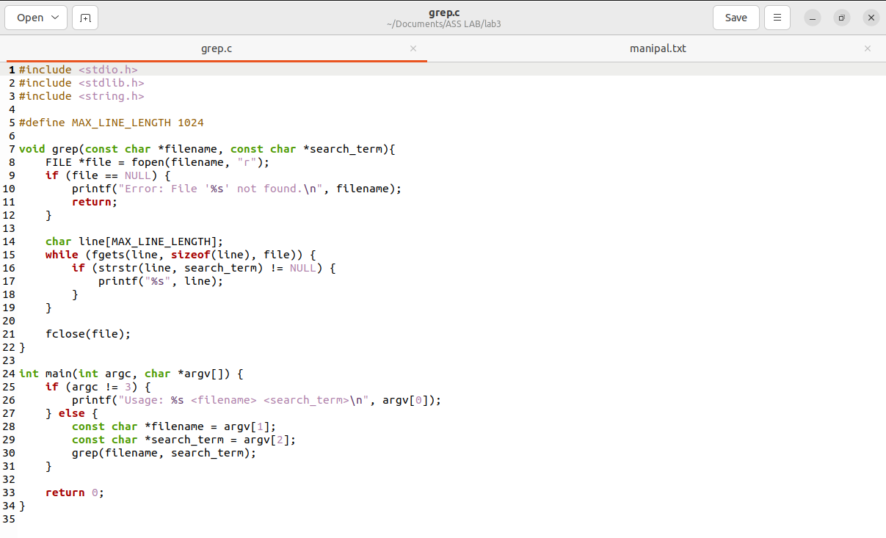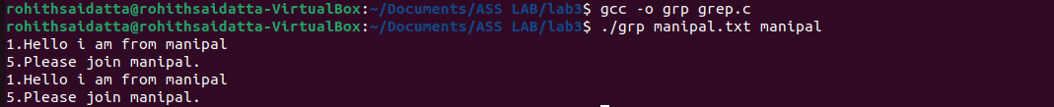

2. Write a program to list the files given as arguments, stopping every 20 lines

until a key is hit. (a simple version of more UNIX utility)

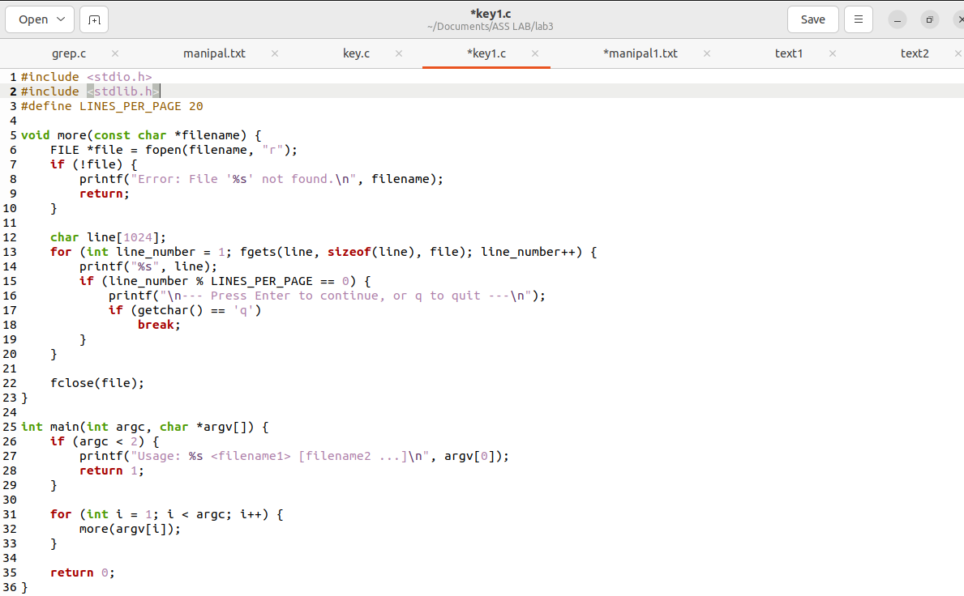

3. Demonstrate the use of different conversion specifiers and resulting output

To allow the items to be printed.

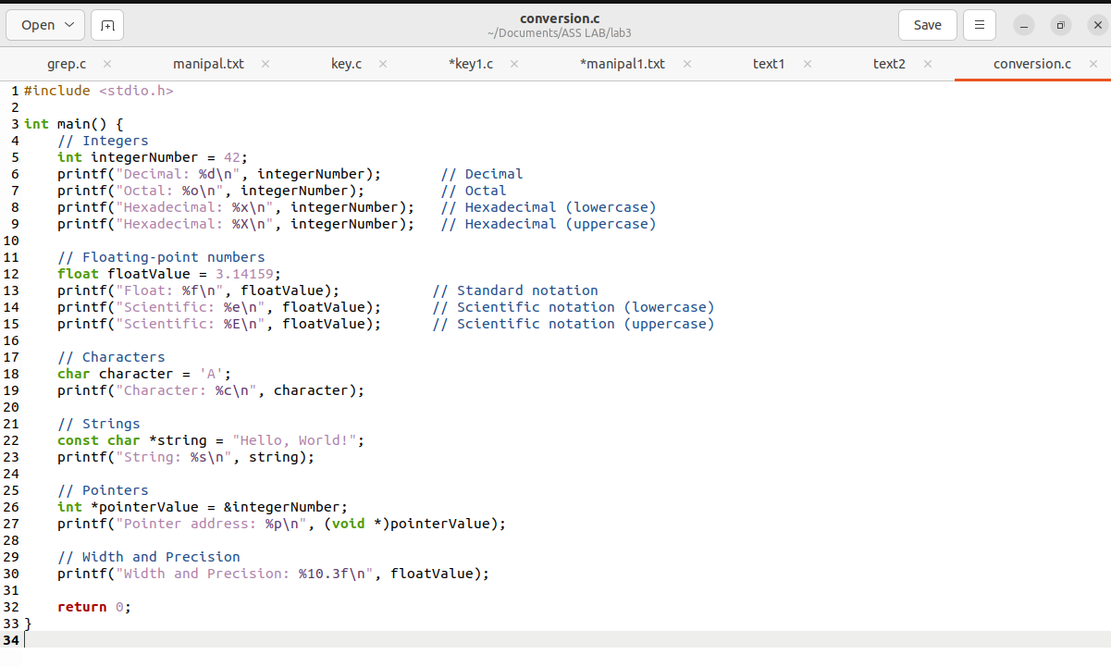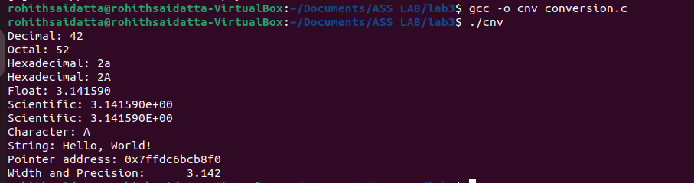

4. Write a program to copy character-by-character copy is accomplished using calls to the functions referenced in stdio.h.

